It provides a means to create structured documents by denoting structural semantics for text such as headings, paragraphs, lists, links, quotes and other items. HTML elements are delineated by tags, written using angle brackets. Tags such as <img /> and <input /> introduce content into the page directly. Others such as <p>...</p> surround and provide information about document text and may include other tags as sub-elements. Browsers do not display the HTML tags, but use them to interpret the content of the page.

HTML can embed programs written in a scripting language such as JavaScript which affect the behavior and content of web pages. Inclusion of CSS defines the look and layout of content.

**4.2.2 CSS**

Cascading Style Sheets (CSS) is a style sheet language used for describing the presentation of a document written in a markup language. Although most often used to set the visual style of web pages and user interfaces written in HTML and XHTML, the language can be applied to any XML document, including plain XML, SVG and XUL, and is applicable to rendering in speech, or on other media. Along with HTML and JavaScript, CSS is a cornerstone technology used by most websites to create visually engaging web pages, user interfaces for web applications, and user interfaces for many mobile applications.

CSS is designed primarily to enable the separation of presentation and content, including aspects such as the layout, colors, and fonts. This separation can improve content accessibility, provide more flexibility and control in the specification of presentation characteristics, enable multiple HTML pages to share formatting by specifying the relevant CSS in a separate .css file, and reduce complexity and repetition in the structural content.

**4.2.3 PHP Language**

PHP is a server-side scripting language designed primarily for web development but also used as a general-purpose programming language. Originally created by RasmusLerdorf in 1994, the PHP reference implementation is now produced by The PHP Development Team. PHP originally stood for Personal Home Page, but it now stands for the recursive acronym PHP: Hypertext Preprocessor.

PHP code may be embedded into HTML or HTML5 markup, or it can be used in combination with various web template systems, web content management systems and web frameworks. PHP code is usually processed by a PHP interpreter implemented as a module in the web server or as a Common Gateway Interface (CGI) executable. The web server software combines the results of the interpreted and executed PHP code, which may be any type of data, including images, with the generated web page. PHP code may also be executed with a command-line interface (CLI) and can be used to implement standalone graphical applications.

**4.2.4. Apache Server**

Apache HTTP Server, colloquially called Apache, is free and open-source cross-platform web server software, released under the terms of Apache License 2.0. Apache is developed and maintained by an open community of developers under the auspices of the Apache Software Foundation.

Apache supports a variety of features, many implemented as compiled modules which extend the core functionality. These can range from server-side programming language support to authentication schemes. Some common language interfaces support Perl, Python, Tcl, and PHP.

Apache features configurable error messages, DBMS-based authentication databases, and content negotiation. It is also supported by several graphical user interfaces (GUIs).It supports password authentication and digital certificate authentication. Because the source code is freely available, anyone can adapt the server for specific needs, and there is a large public library of Apache add-ons.

**4.2.5 MySQL Database**

MySQL is a Relational Database Management System (RDBMS). MySQL server can manage many databases at the same time. In fact, many people might have different databases managed by a single MySQL server. Each database consists of a structure to hold the data and the data itself. A data-base can exist without data, only a structure, be totally empty, twiddling its thumbs and waiting for data to be stored in it.

Data in a database is stored in one or more tables. You must create the data-base and the tables before you can add any data to the database. First you create the empty database. Then you add empty tables to the database. Database tables are organized like other tables that you’re used in rows and columns. Each row represents an entity in the database, such as a customer, a book, or a project. Each column contains an item of information about the entity, such as a customer name, a book name, or a project start date. The place where a particular row and column intersect, the individual cell of the table, is called a field. Tables in databases can be related. Often a row in one table is related to several rows in another table. For instance, you might have a database containing data about books you own. You would have a book table and an author table. One row in the author table might contain information about the author of several books in the book table. When tables are related, you include a column in one table to hold data that matches data in the column of another table.

* + 1. **What is MySQL?**

MySQL, the most popular Open Source SQL database management system, is developed, distributed, and supported by MySQL AB. MySQL AB is a commercial company, founded by the MySQL developers. It is a second-generation Open Source company that unites Open Source values and methodology with a successful business model.

* MySQL is a database management system.

A database is a structured collection of data. To add, access, and process data stored in a computer database, you need a database management system such as MySQL Server. Since computers are very good at handling large amounts of data, database management systems play a central role in computing, as standalone utilities, or as parts of other applications.

* MySQL is a relational database management system.

A relational database stores data in separate tables rather than putting all the data in one big storeroom. This adds speed and flexibility. The SQL part of “MySQL” stands for “Structured Query Language.” SQL is the most common standardized language used to access databases and is defined by the ANSI/ISO SQL Standard.

* MySQL software is Open Source.

Open Source means that it is possible for anyone to use and modify the software. MySQL Server was originally developed to handle large databases much faster than existing solutions and has been successfully used in highly demanding production environments for several years

* MySQL Server works in client/server or embedded systems.

The MySQL Database Software is a client/server system that consists of a multi-threaded SQL server that supports different back ends, several different client programs and libraries, administrative tools, and a wide range of application programming interfaces (APIs).

**4.2.7 Wampserver64**

Wampserver64 installs a complete and ready-to-use development environment. Wampserver64 allows you to fit your needs and allows you to setup a local server with the same characteristics as your production.

In case of setting up the server and PHP on your own, you have two choices for the method of connecting PHP to the server. For many servers PHP has a direct module interface (also called SAPI). These servers include Apache, Microsoft Internet Information Server, Netscape and iPlanet servers

* 1. **Discussion of the Code**

**4.3.1 Home page**

In the below fig 4.3.1, a faculty has three options

* Home: This is the home page / Default page for the website which has default details/anchor ref for different details.
* Advance:This page contains advance options like admin-login and User log-in options.
* Sign-up:This page contains new user to Sign-up options, Sign-up details directly go to the database.
* Players:This page will show Players details,user can see batsman,Bowlers and All-rounders available to select for there Team.
* Teasm:This will show the number of teams present at the moment with there team rankings.

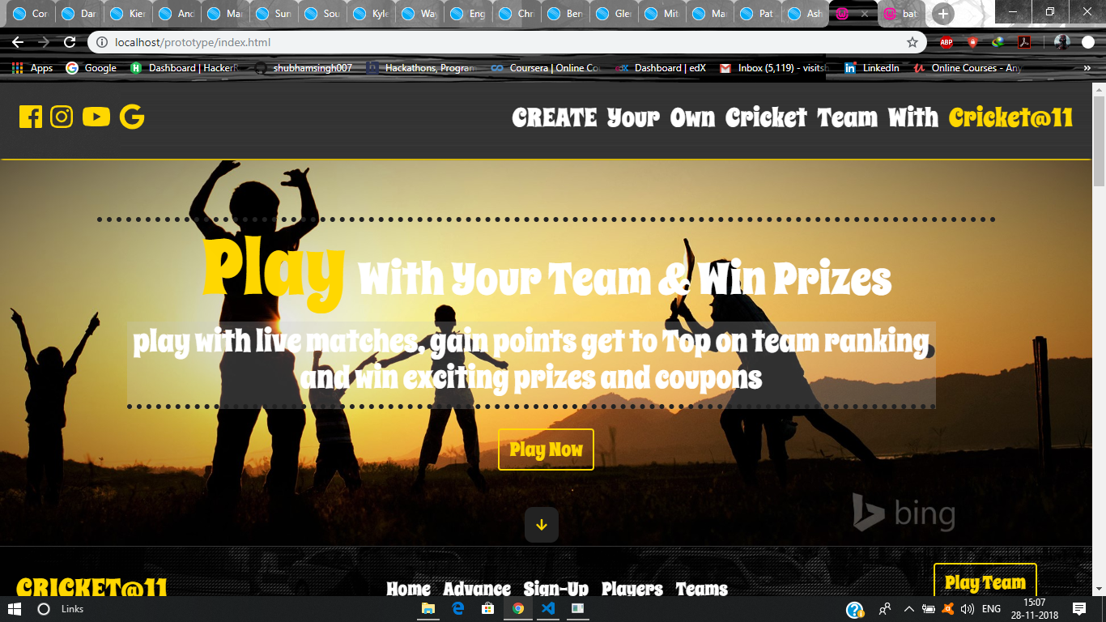

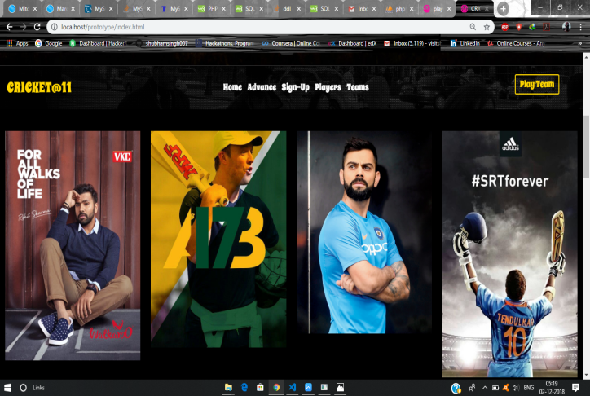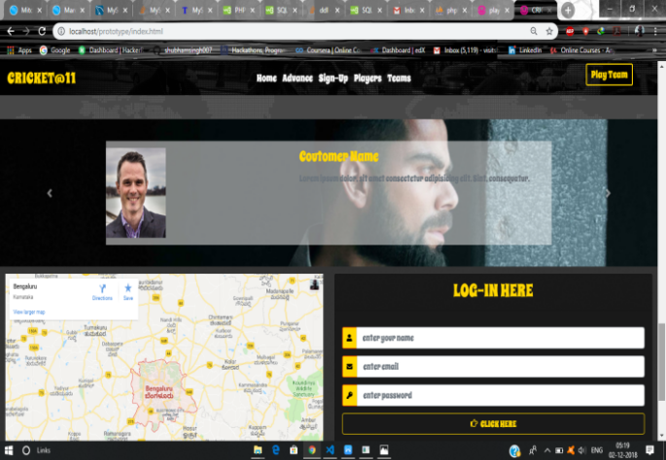

**4.3.2 Sign-Up Page**

In the below fig 4.3.2, user can create a new Account.

After submitting the details by clicking to sign-up button,new account is created and data filled by the user is save in the database in User table,from where data can be used for future Log-in purpose. Here two user cannot have same team name.

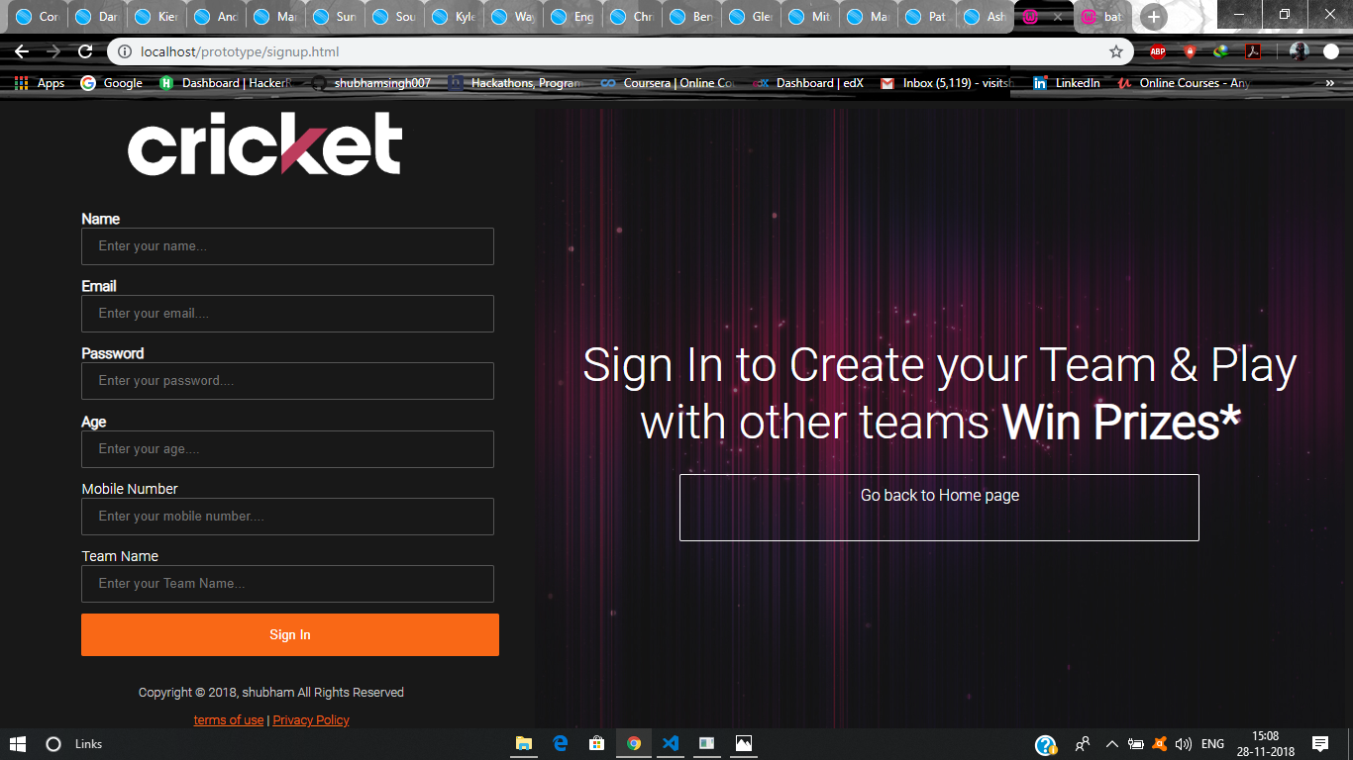

|  |
| --- |
|  |

Fig 4.3.2 user sign-up

**4.3.3 User Log-In/Admin Log-In**

In the below Fig 4.3.3 the user who already have a account can successfully log in for further creating / viewing there own team details .

If you enter the correct email and password, then you will get into next page else it will redirect you to home page.

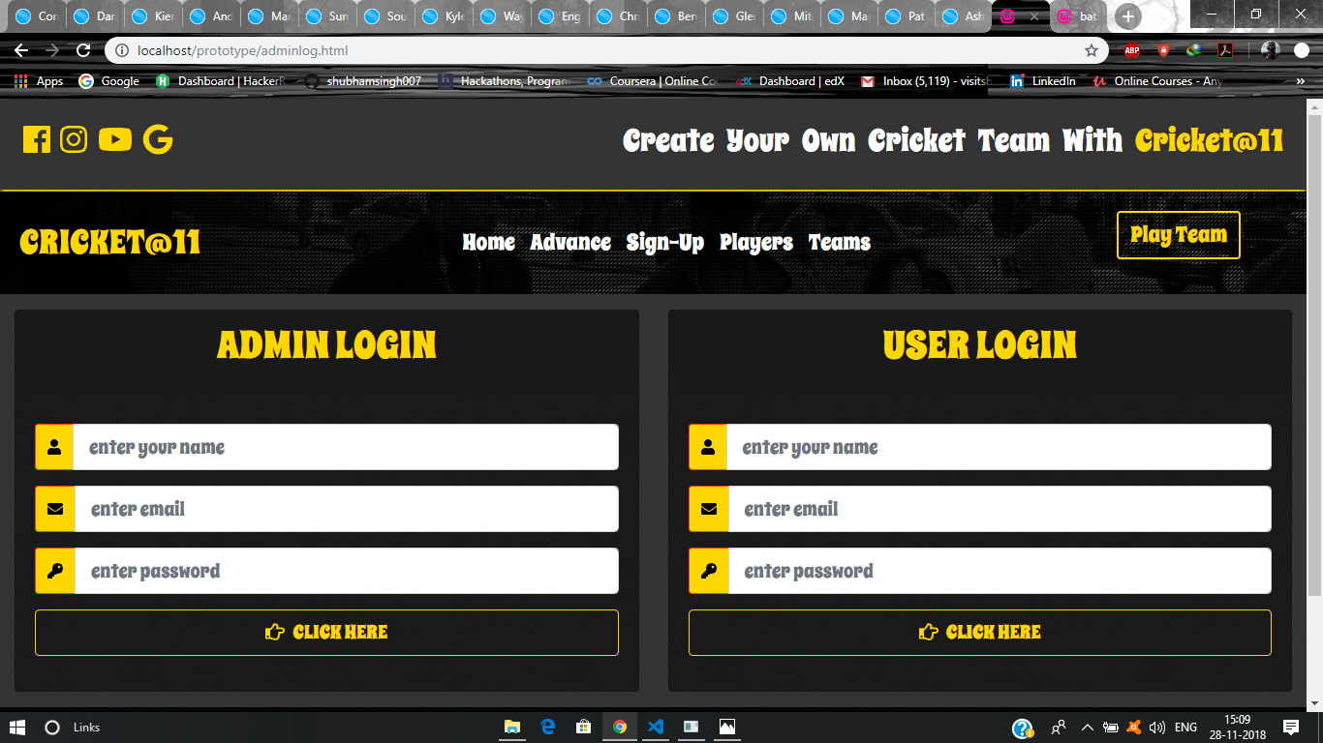

Fig 4.3.3 User log-in/Admin log-in

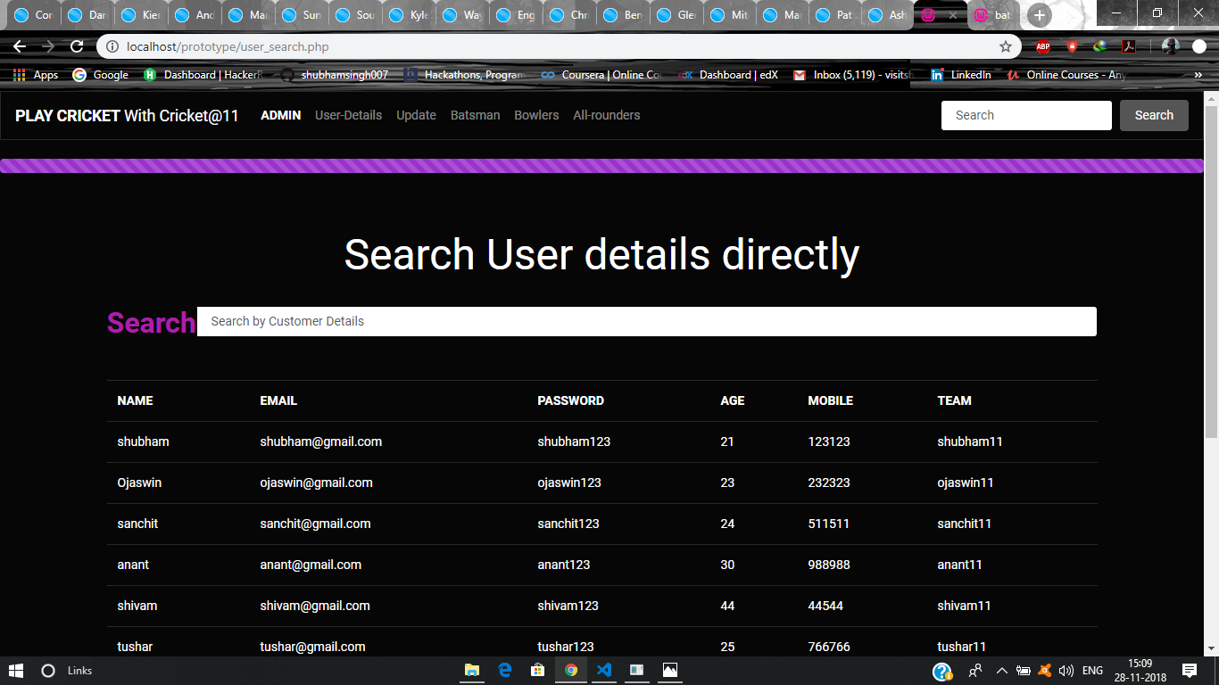

Fig user details

**4.3.4 Search Batsman**

In the below figure fig 4.3.4, User can search batsman with there record and can select batsman according to it.

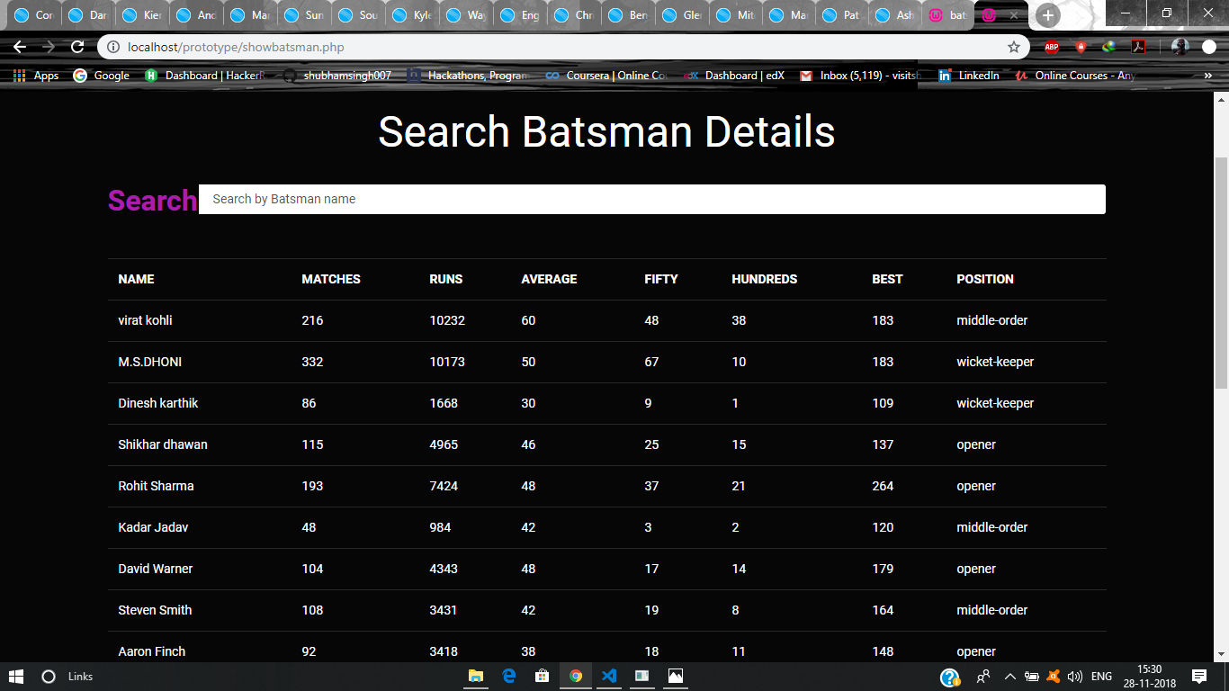

Search all-rounders with details.

Like wise batsman bowlers and all-rounders , user can also see bowlers and all-rounders details,

And if it want to add these players to it team it can do it by log-in to its account and selecting these players to its team.

In next page user can see all-rounders details as well and can log-in to to is account add add these players to its team.

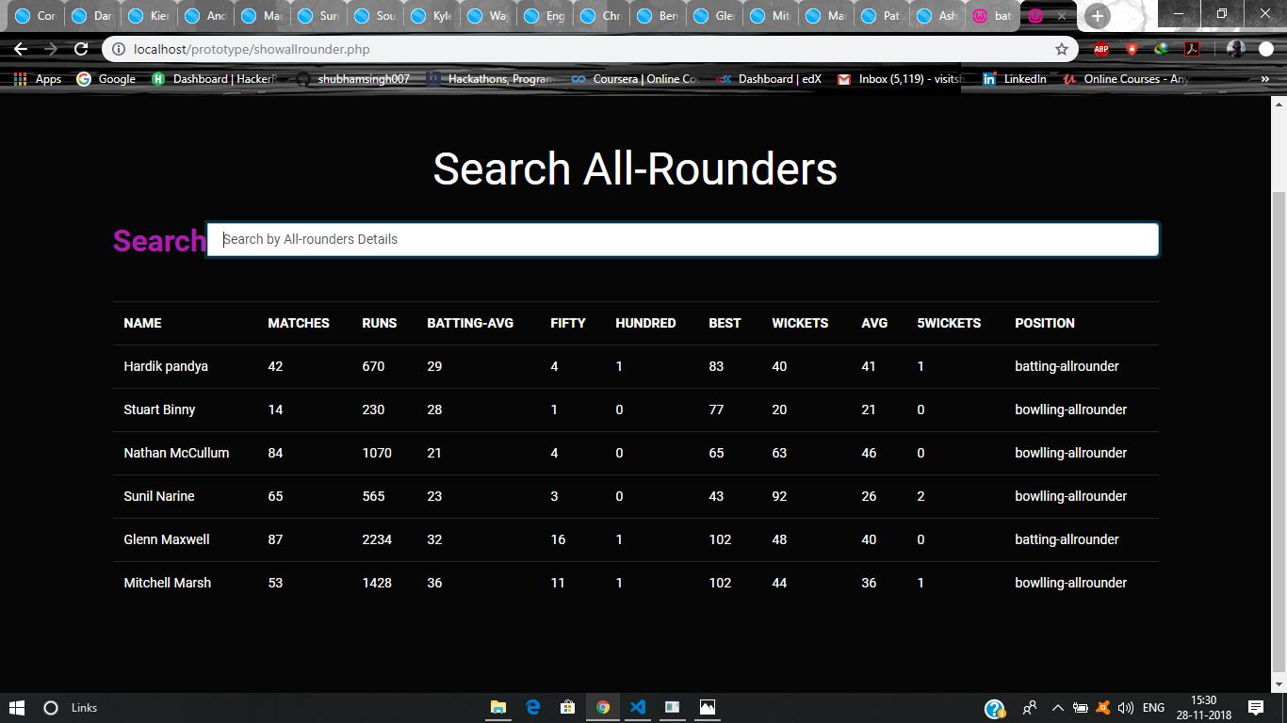

**4.3.5 ADD batsman,Bowlers and all-rounders to database**

Only admin can add new players to database by accessing admin account and filling new players to the database.

In below example admin can add new bats to database by filling following details to the add new batsman Form:

Add player name,

Numbers of matches played

Runs scored

Batting Average

Hundred / Fifty scored

Highest score

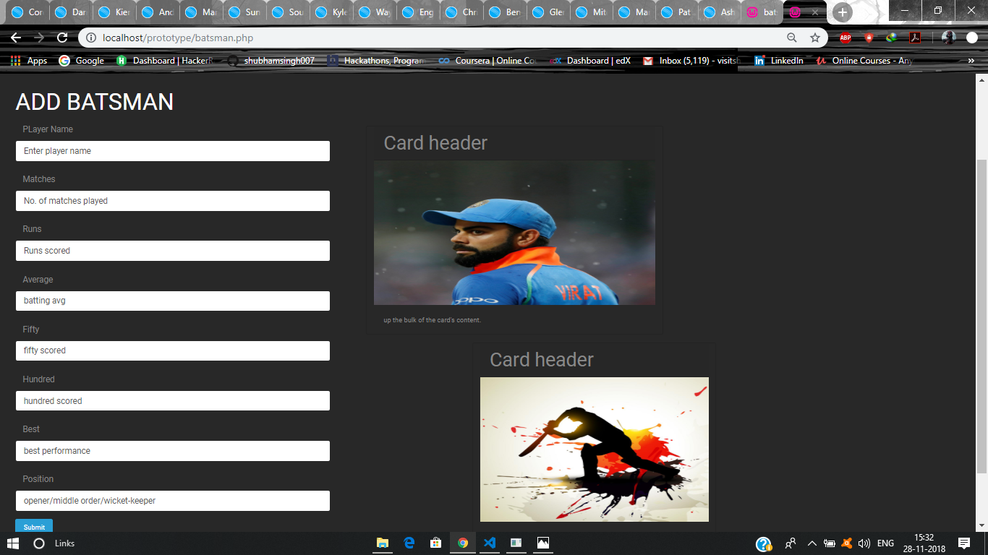

Fig 4.3.5 Add new batsman

* + 1. **Update batsman ,Bowler and all-rounder details**

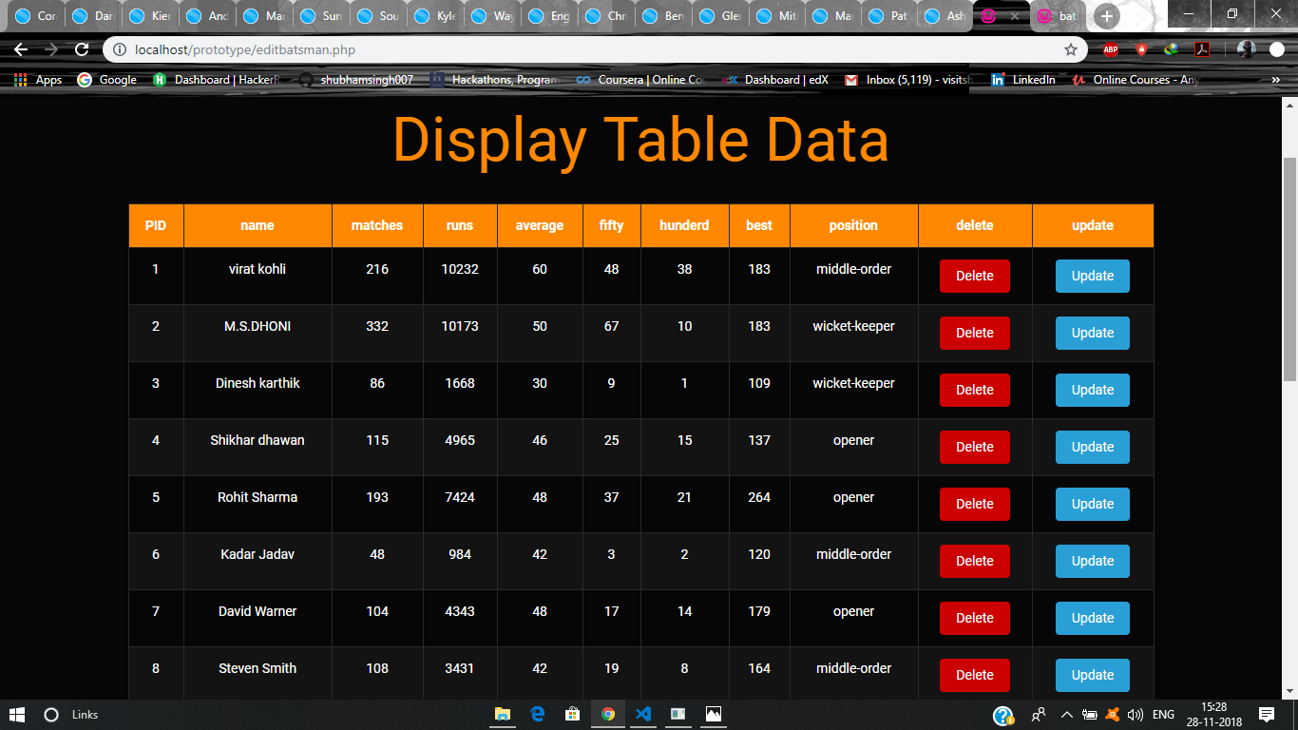

* 1. **Code snapshot**

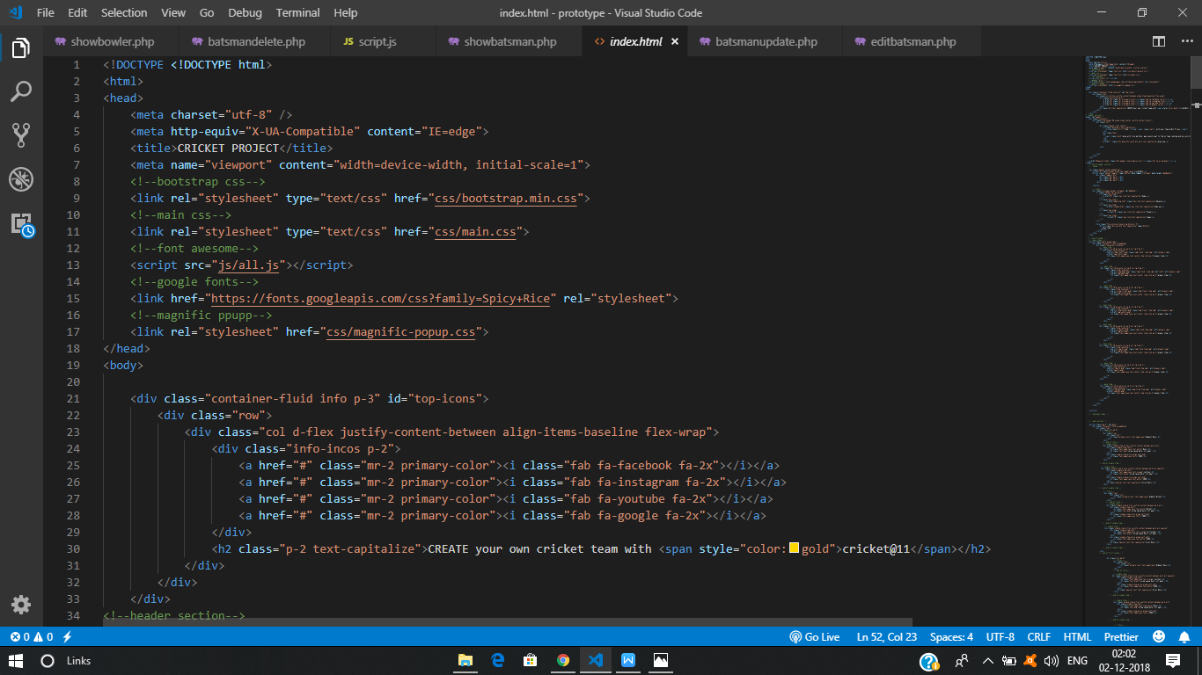

**Home page**

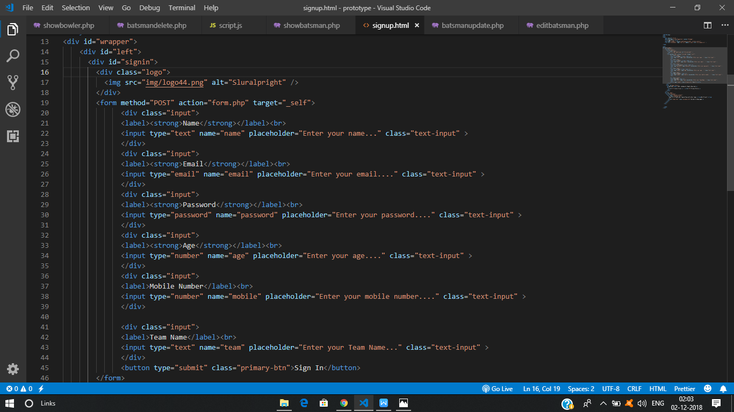

**Sign-up page**

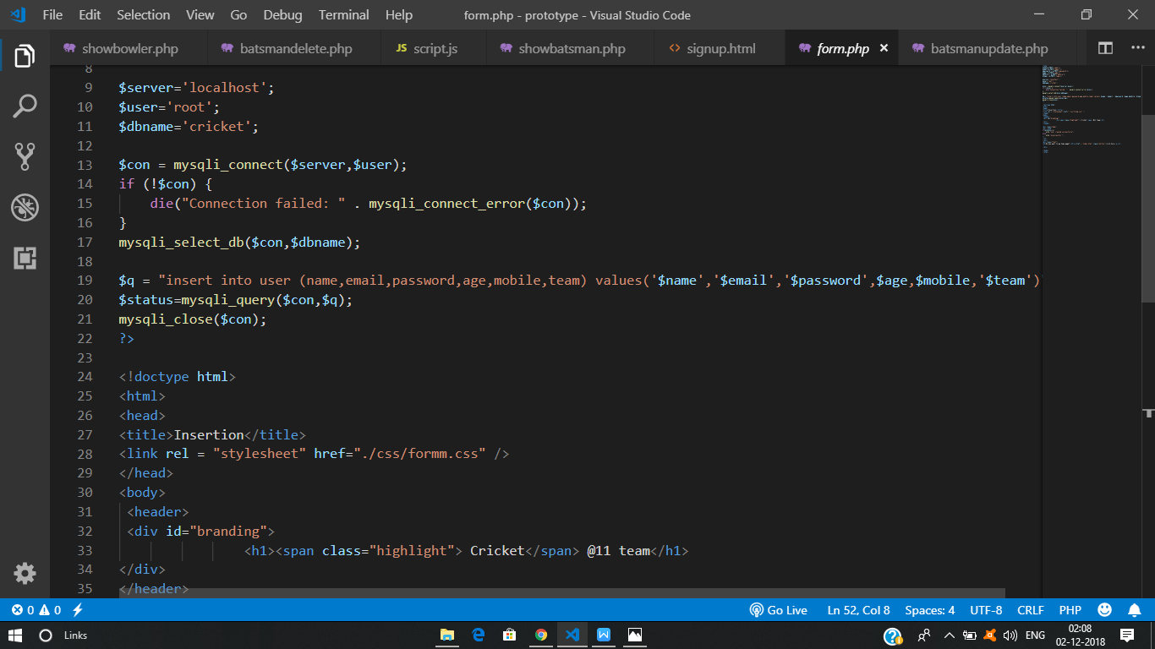

**Insert user data into database**

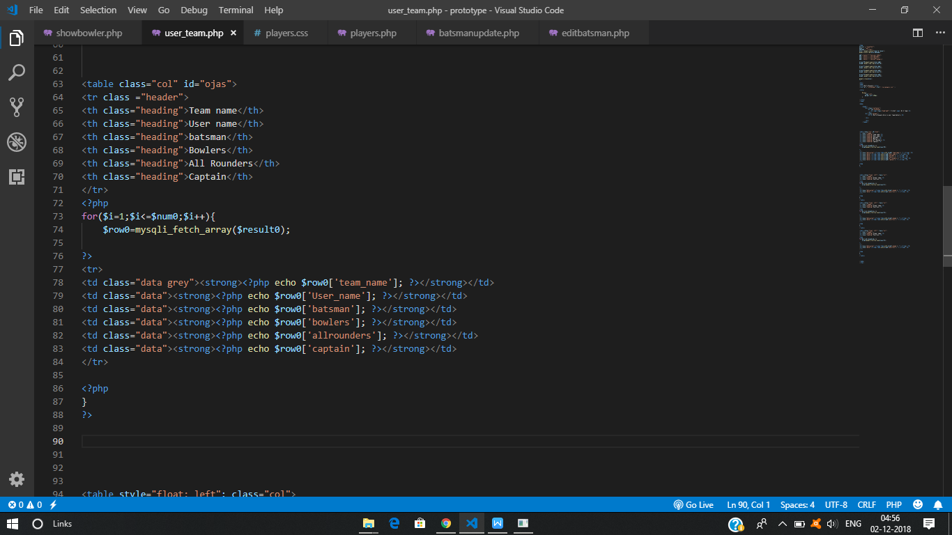

**User team details**

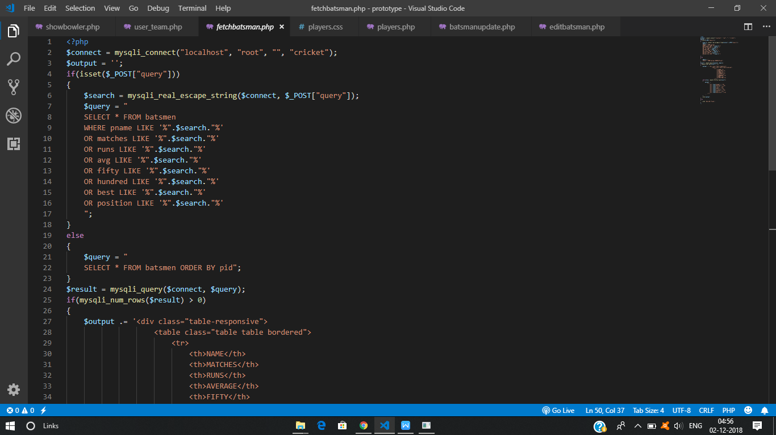

**Batsman details**

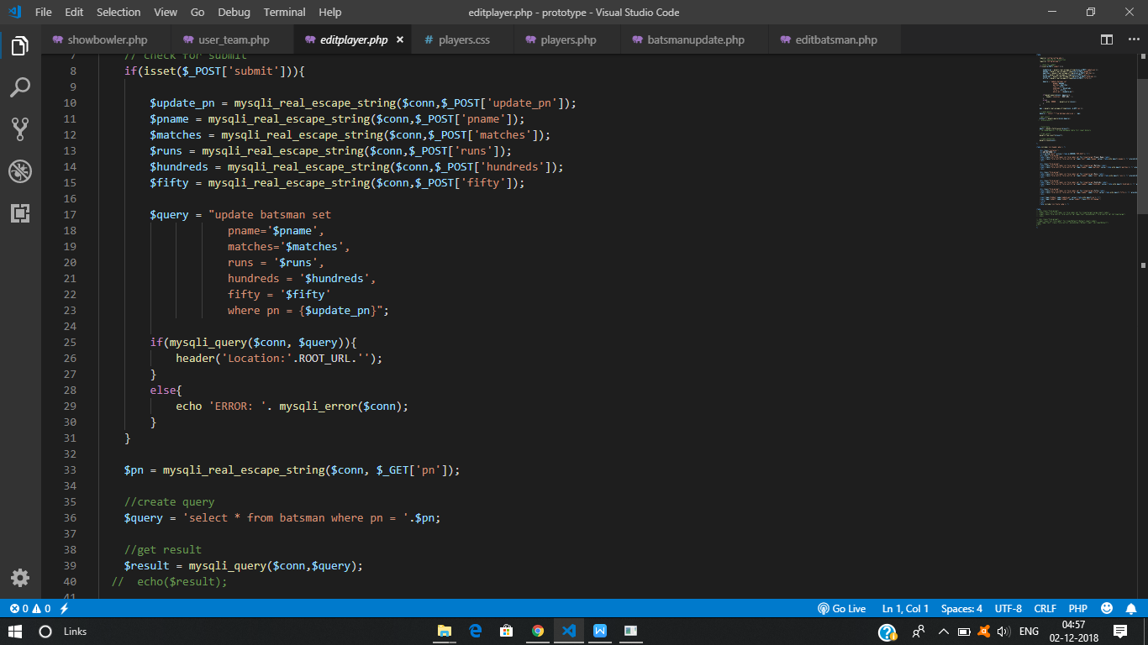

**Update player Records**

**Final User Team Details**

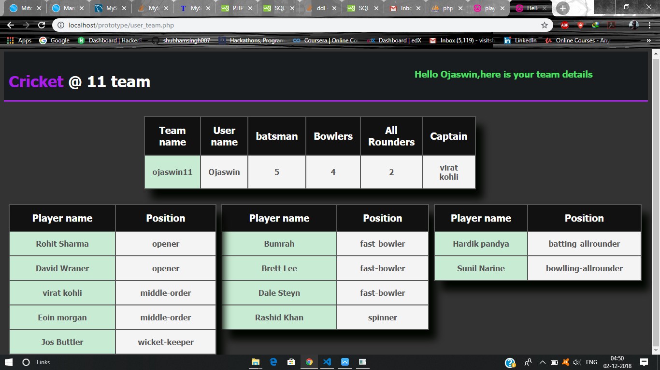

* 1. **Discussion of the Results**
* The given project is able to store the User team with its team information so that user can see, compare its team with others.
* The User can log in to see its team with number of Batsman , Bowlers and All-rounders contributing to the team.
* User can Add, Update and Delete players from its Team and can change players position like any other real world team.
* Not only user can make its own team but also can see origin records of Batsman, Bowlers and All-rounders around the world(**project can also acts like cricket database**).
* Project gives a healthy user experience and is also responsive, and easy to maintain new records(new teams, new players, updated records) in the database.